
CENTRAL WEST EDUCATION DIVISION
2026 MALAWI SCHOOL CERTIFICATE OF EDUCATION
MOCK EXAMINATIONS

GEOGRAPHY PAPER II
(100 Marks)
HUMAN AND ECONOMIC GEOGRAPHY
MARKING KEY

SECTION A (75 marks)
Answer all three questions in this section in the space provided.
 |  |  | Any two economic factors, 2 marks each  - Capital – can be used to construct farm buildings, purchase machinery, fertilizer, seeds and insecticides.  - Markets and transport: nearness to markets overall costs. Perishable and bulky goods need to be produced near markets for freshness and reduce transport costs.  - Technology or mechanization: high mechanization and technology determine a type of agriculture to be practised.  - Use of fertilizer: when land lose its fertility, there is need to apply chemical fertilizer which is costly. | (4 marks)
 |  |  | Any two characteristics of intensive farming systems for 1 mark each  - It is labour intensive  - Done on small farms  - It leads to high output per unit area.  - High cost of land  - Intensive land use  - Market-orientated where the surplus is sold. | (2 marks
 |  |  | Any two sources of water for irrigation in Israel for 1 mark each  - River Yarkon  - Lake Kinerat/ Tiberians/ Sea of Galilee  - Jordan River  - Dead Sea  - Mediterranean Sea  - Ground water | (2 marks)
 |  |  | Factors affect irrigation farming in Israel.  - Relief  - Relief – rugged which promotes pumping of water from low altitude to other water deficient areas through pipes. Water is pumped from areas that are below sea level hence expensive to supply water. | (2 marks)
 |  |  | - Salinity  - Salinity – most water sources are saline due to high temperatures, hence require purification which is very expensive to carry out. | (2 marks)
 |  |  | Any two advantages of sprinkler method of irrigation for 2 marks each | (4 marks)
- Reduces water wastage because water supply can be regulated as water falls in droplets form/ does not use much water since water is spread evenly to crops.
- Enables uniform application of pesticides and fertilizer with water.
- Can be used on any terrain since water is pumped/ does not require much levelling of land since pressure is used to pump water against gravity.
- Soil erosion is reduced.
 |  |  | Any two districts where tea is grown in Malawi for 1 mark each. | (2 marks)
- Thyolo
- Mulanje
- Nkhatabay
 |  |  | Any two physical conditions which influence tea farming (for 2 marks each) | (4 marks)
- Deep well drained loam fertile soils
- Presence of highland areas with flat slopes on top to allow good drainage of water.
- Presence of shade that is provided by shade trees.

 |  |  | What is the importance of each of the following in tea processing:
 |  |  | - Withering  - Withering – makes tea leaves to lose moisture by 50%, Makes tea leaves soft for each rolling. | (1 mark)
 |  |  | - Fermentation
 |  |  | - Fermentation – reduces caffeine or tannic acid, to preserve its strong flavour, to change green colour of leaves to copper. | (1 mark)
 |  |  | - Firing
 |  |  | - Firing – removes the remaining water from tea leaves, changes the colour of leaves to black. | (1 mark)
Figure 1 shows the fishing grounds of the world. Use it to answer the questions that follow.
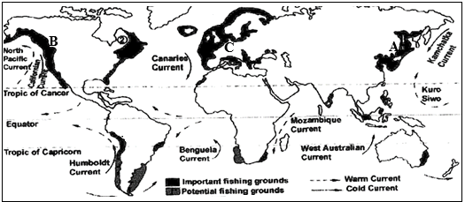
 |  |  | Identify the fishing grounds marked A and B.  A: North Western Pacific | (1 mark)
 |  |  | B: North eastern pacific | (1 mark)
 |  |  | - There are vast continental shelves with abundant planktons for fish growth.  - Meeting of North Atlantic drift and labrador ocean currents encourages rapid growth of planktons.  - Lack of natural resources which have forced people to the sea for livelihood.  - Cool temperature climate which favours the preservation of fish.  - Presence of Shallow waters which catalyses the process of photosynthesis in planktons.  - Many rivers drain into it depositing large quantities of nutrients for plankton growth. | (4 marks)
 |  |  | Any one resource from the sea (for 1 mark)  - Minerals (phosphates, sulphur, bromine, sodium chloride, magnesium, potassium).  - Fresh water  - Oil  - Salt  - Sea weeds  - Prawns  - Natural gas  - Shells  - Metals (tins, diamond, iron, aragonite, gold and manganese). | (1 mark)
 |  |  | Any two challenges faced by the fishing in Malawi (for 1 mark each).  - Increased siltation of water bodies due to soil erosion upland.  - Use of improper fishing methods.  - Overfishing  - Pollution of the water bodies | (2 marks)
 |  |  | Define the term “trade blocs”. (for 1 mark)  - Regional groupings formed by countries to improve trade and remove trade restrictions. | (1 mark)
 |  |  | Any two challenges faced by trade blocs (for 2 marks each.)  - Free trade affects local industries which are not taxed hence affects price.  - Women are affected by well documented gender specific areas that affect their potential in trade.  - Professionalism affects trade.  - Harassment of women traders discourage them from trade.  - There are losses due to payment of concessions.  - High cost of goods entering countries reduce returns investments due to high tax.  - Political differences among member states affects trade negatively.  - Disparities in trade make it difficult to harmonize common external tariffs.  - VISA restrictions discourage businesses.  - Civil wars cause insecurities that affect trade negatively. | (4 marks)
 |  |  | Any two ways in which Malawi benefit (for 2 marks each).  - Access to regional markets increased the volume of trade.  - Attract investment which promote economic growth.  - Collaboration on regional infrastructure projects.  - There are joint effects on climate change mitigation and adaptation.  - There is promotion of cultural understanding and exchange.  - There is easier access to regional education and training opportunities. | (4 marks)
 |  |  | Any two factors that influence tourism in Africa (for 2 marks each).  - Warm tropical climates/ sunny conditions/ pleasant climate.  - Presence of game/ wildlife.  - Natural waterfalls.  - Wide variety of lakes and rivers.  - Coastal beaches | (4 marks)
 |  |  | Any one way in which ecotourism is important (for 1 mark).  - Educates the local people on environmental conservation thereby empowering them.  - It offers employment opportunities to the local people, thereby increasing their incomes.  - It discourages poaching which contributes positively the protection of wildlife.  - It encourages participation of local communities in making decisions about the environment.  - It helps to conserve natural and cultural heritage | (1 mark)
 |  |  | Main aim of the international agreements on climate (for 2 marks each).
 |  |  | - Copenhagen Accord  - Aims at limiting global temperature rise to 2⁰c. | (2 marks)
 |  |  | - Kyoto Protocol  - Aims at reducing the emission of greenhouse gases by developed counties and transition economies. | (2 marks)
 |  |  | Define the term energy crisis (for 1 mark)  - Situation where energy becomes scarce for most of the people in a particular area. Or it is any great shortfall in the supply of energy. | (1 mark)
 |  |  | Any three possible solutions for energy crisis in Malawi (for 1 mark each).  - Use of alternative sources of energy e. g wind water solar.  - Improve technology on conversion of fossil fuels to electricity.  - Using energy – efficient products such as energy saving stoves and LED bulbs which use less watts of electricity. | (3 marks)
Figure 2 shows a process of energy production. Use it to answer questions that follow.
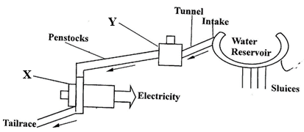

 |  |  | Name the parts labelled X and Y (for 1 mark each).  X. Turbine  Y. Surge chamber | (2 marks)
 |  |  | How the energy is produced in Figure.  - Running water from the reservoir (1 mark) is directed to the penstocks through surge chamber (1 mark), The running water gains more kinetic energy and moves with great speed(1 mark). The water is then directed to the powerhouse where it rotates the turbines(1 mark) which spin generators to produce electricity (1 mark).  OR  - Water from a dam or river (1 mark) pass through penstocks by gravity (1 mark). It is then led to hit the blades of the turbine wheels which causes rotation (1 mark).The rotating wheel produced mechanical energy which is converted into electrical energy by the generators connected to the turbines(1 mark). | (4 marks)
 |  |  | Any two factors that influence power generation in (i) above (for 2 marks each).  - Presence of steep slopes which encourage the fast flow of water for rotating the turbines.  - Readily available market to use the power generated.  - Presence of large water volumes to run the machines.  - Large capital to purchase the power station machines. | (4 marks)
 |  |  | Any two examples of underground mining methods (for 1 mark each).  - Shaft mining  - Adit (drift)  - Solution  - Drilling  - Deep sea mining | (2 marks)
 |  |  | Any two ways for thr importance of mining (for 2 marks each).  - Mining provides employment opportunities both directly and elsewhere.  - Minerals can be exported to earn forex.  - Infrastructural development: such as roads, electricity to areas where mining takes place.  - Revenue – mining reaps huge profits to the government since it is a source of revenue through tax.  - Development of settlement and towns. | (4 marks)
 |  |  | Any two negative effects of mining on the environment (for 2 marks each).  - Damages ecosystem – tears up and later abandoned many areas thereby destroying habitats and ecosystems.  - It leads to air pollution due to the release dust which is suspended in the air.  - It leads to land pollution as land is left unattractive.  - Loss of soil fertility especially through surface mining where top layer of soils is excavated. | (4 marks)
 |  |  | Any one use of aluminium (for 1 mark).  - Making bodies of automobiles bottling and canning.  - Aluminium foil for packaging  - Making Electrical wires  - Making Cooking utensils  - Making Window frames | (1 mark)
SECTION B (25 Marks)

Answer one question only from this section in the spaces provided

 |  |  | Any two shapes of population pyramid (for 1 mark each).  - Expansive/ expanding/ triangular  - Stationary/ stable/ rectangular  - Decline/ constructive | (2 marks)

Figure 3 shows a population pyramid of country X. Use it to answer the questions that follow.
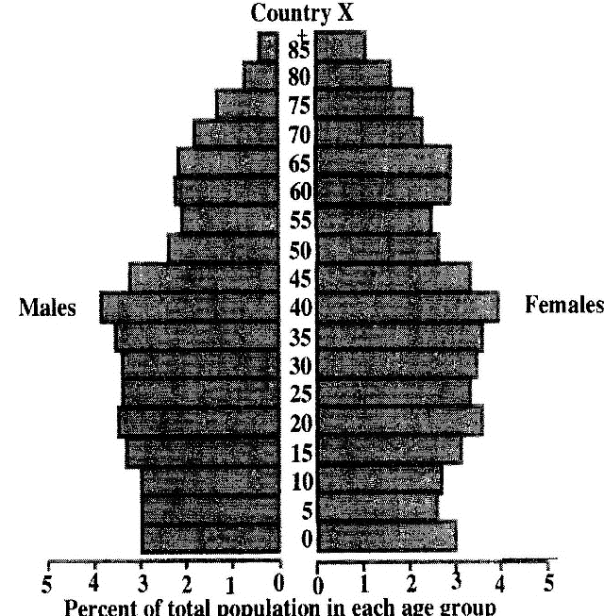

 |  |  | Any two observations from the population pyramid in Figure 3 (for 1 mark each).  - High dependency ratio of the elderly but very low of the youth.  - It has low death rate  - It has low birth rate  - It has long life expectancy  - There are more older women than men.  - There is small youthful population. | (2 marks)
 |  |  | Any two implications of the population structure in (ii) above (for 2 marks each).  - Migrants move into the country.  - There is more money for investment and development.  - There is better health care.  - There is Improved economies.  - Improved social status of then people.  - Better and efficient use of resources.  - There are few workers left to fill all the jobs. | (4 marks)
 |  |  | Any two crops grown on dairy farms (for 1 mark each).  - Wheat,  - burley,  - rape seed,  - vegetables,  - potatoes,  - sugar beet,  - maize,  - oats,  - grass seeds | (2 marks)
 |  |  | Any two interventions to improve dairy industry in Malawi (for 2 marks each).  - Training farmers in basic skills concerning dairy farming like making cattle feeds.  - Offering loans to dairy farmers to increase production.  - Providing cooling centres for preservation of milk.  - Providing veterinary services such as artificial insemination to improve dairy breeds. | (4 marks)
 |  |  | In what kind of rocks is petroleum found (for mark).  - Sedimentary rock | (1 mark)
 |  |  | Any two negative impacts of drilling oil in Lake Malawi (for 2 marks each).  - Ecosystem damage  - Pollution of the water body  - Climate change  - Acid rain  - Fires and explosion  - Chronic occupation hazards  - Depletion of surface water. | (4 marks)
 |  |  | Any two roles played by OPEC in the petroleum industry (for 2 marks each).  - Co-ordinate and unify the petroleum policies of the member countries.  - To seek stabilisation of prices in international oil markets.  - To provide efficient, economic and regular supply of petroleum. | (4 marks)
 |  |  | Give a reason why the following activities are done in rice fields:
 |  |  | - Controlling water level (for 2 marks).  - To prevent submerging of rice plants. | (2 marks)
 |  |  | - Puddling of soil (for 2 marks).  - To break big soil clods. | (2 marks)
Figure 4 is a settlement pattern. Use to answer questions that follow:
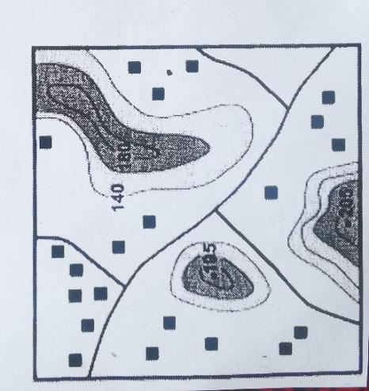
 |  |  | Identify the settlement pattern in the figure above (for 1 mark)  - Scattered | (1 mark)

 |  |  | Any two factors influence the development of the pattern (for 2 marks each).  - The area does not have enough people to work.  - There are few people to socialise, hence no exchange of ideas. | (4 marks)
 |  |  | Any two disadvantages of the settlement pattern (for 2 marks each).  - There is slow development since diffusion of innovations and new ideas tend to be slow as people are isolated.  - People travel long distance to access social services like health care, shops and even education.  - Limited and insufficient natural resources like water supply and fertile land.  - Geographical barriers like hills, mountains.  - Land inheritance as a form of land tenue and extensive farming systems.  - Politically stable and peaceful environment in case there is no need for people to group together for protection. | (2 marks)
 |  |  | Anytwo factors that influence urbanization (for 2 marks each).  - Rural-urban migration  - High birth rates than dearth rates/ natural increase. | (4 marks)
 |  |  | State any one solution for each of the following challenges associated with urbanization:  - Traffic congestion (dor 1 mark)  - Providing parking areas  - Providing free ways, highways, one way street.  - Imposing fees for car entry into CBD.  - Constructing fly overs  - Imposing high vehicle inspection fees  - Encouraging people to be using public transport as opposed to private vehicles.  - Using by-pass roads which lessen pressure on available road to the CBD when drivers have nothing to do in the CBD. | (1 mark)
 |  |  | - Unemployment (for 1 mark)  - Providing parking areas  - Providing free ways, highways, one way street.  - Imposing fees for car entry into CBD.  - Constructing fly overs  - Imposing high vehicle inspection fees  - Encouraging people to be using public transport as opposed to private vehicles.  - Using by-pass roads which lessen pressure on available road to the CBD when drivers have nothing to do in the CBD. | (1 mark)
 |  |  | Any two ways of managing wastes (for 1 mark each).  - Encouraging the society to be re-using some of the products several times before they are disposed.  - Some of the products must be recycled and produce another new product than burning it to ashes because burning it encourages air pollution. | (2 marks)
 |  |  | Any two economic effects of poor waste disposal (for 1 mark each).  - When the cities or urban areas have wastes disposed poorly, they do not attract tourists because of bad smell and do not look attractive.  - Poor waste disposal is a threat to investment and loss of income, becomes a danger since investors cannot open economic activities in the area.  - Some institutions are closed by the government officials if the institutions dispose their wastes poorly like restaunts, hence loss of business. | (4 Marks)
Figure 5 is the map of the world showing major industrial areas. Use it to answer questions that follow.
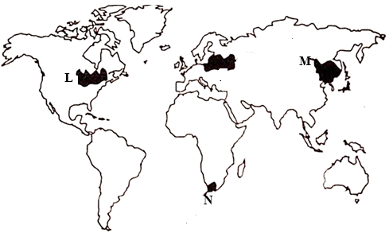
 |  |  | Name the industrial regions marked L and M (1 mark each).  - L: North East USA/ Canada/ North America  - M: South Africa/ Republic of South Africa. | (2 marks)
 |  |  | Any two factors which have influenced the development of N (for 2 marks each).  - Abundance of raw materials like Iron, coal which provide raw materials for industries.  - Well-developed transport networks  - Presence of sources of power like HEP and coal.  - Large population which provides a ready market for manufacturing.  - High technological advancement. | (4 marks)

END OF QUESTION PAPER

